**VLSI LAB REPORT: LAB 2**

**Student Name: Trịnh Văn Đức**

**Student ID: ITITIU21182**

**Instructor: Mr. Nguyen Binh Duong**

**LAB 2: SYMBOL CREATION & PRE-LAYOUT SIMULATION**

**1. Introduction**

Building on the first lab, this session focused on creating a **Symbol view** for the inverter. This is a crucial step for hierarchical design, allowing us to reuse this inverter as a block in larger circuits. I also ran parametric simulations to see how changing the transistor width affects performance.

**2. Symbol Creation**

I generated the symbol directly from my schematic view. To adhere to standard logic conventions, I edited the default box shape into a triangle with a circle at the output tip.

The symbol includes four pins:

* Inputs/Outputs: A and Y.
* 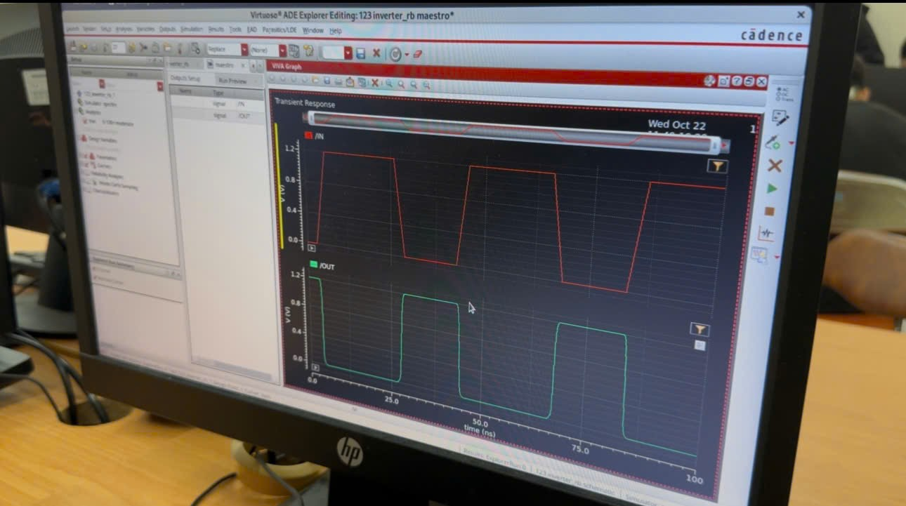Supply Rails: VDD and VSS 6.

**3. Parametric Sweep Simulation**

One of the most interesting parts of this lab was seeing the effect of transistor sizing.

* I set up a design variable w for the transistor width.
* Using ADE Explorer, I ran a **Parametric Sweep**, varying w from **120 nm** to **720 nm**.

Observations:

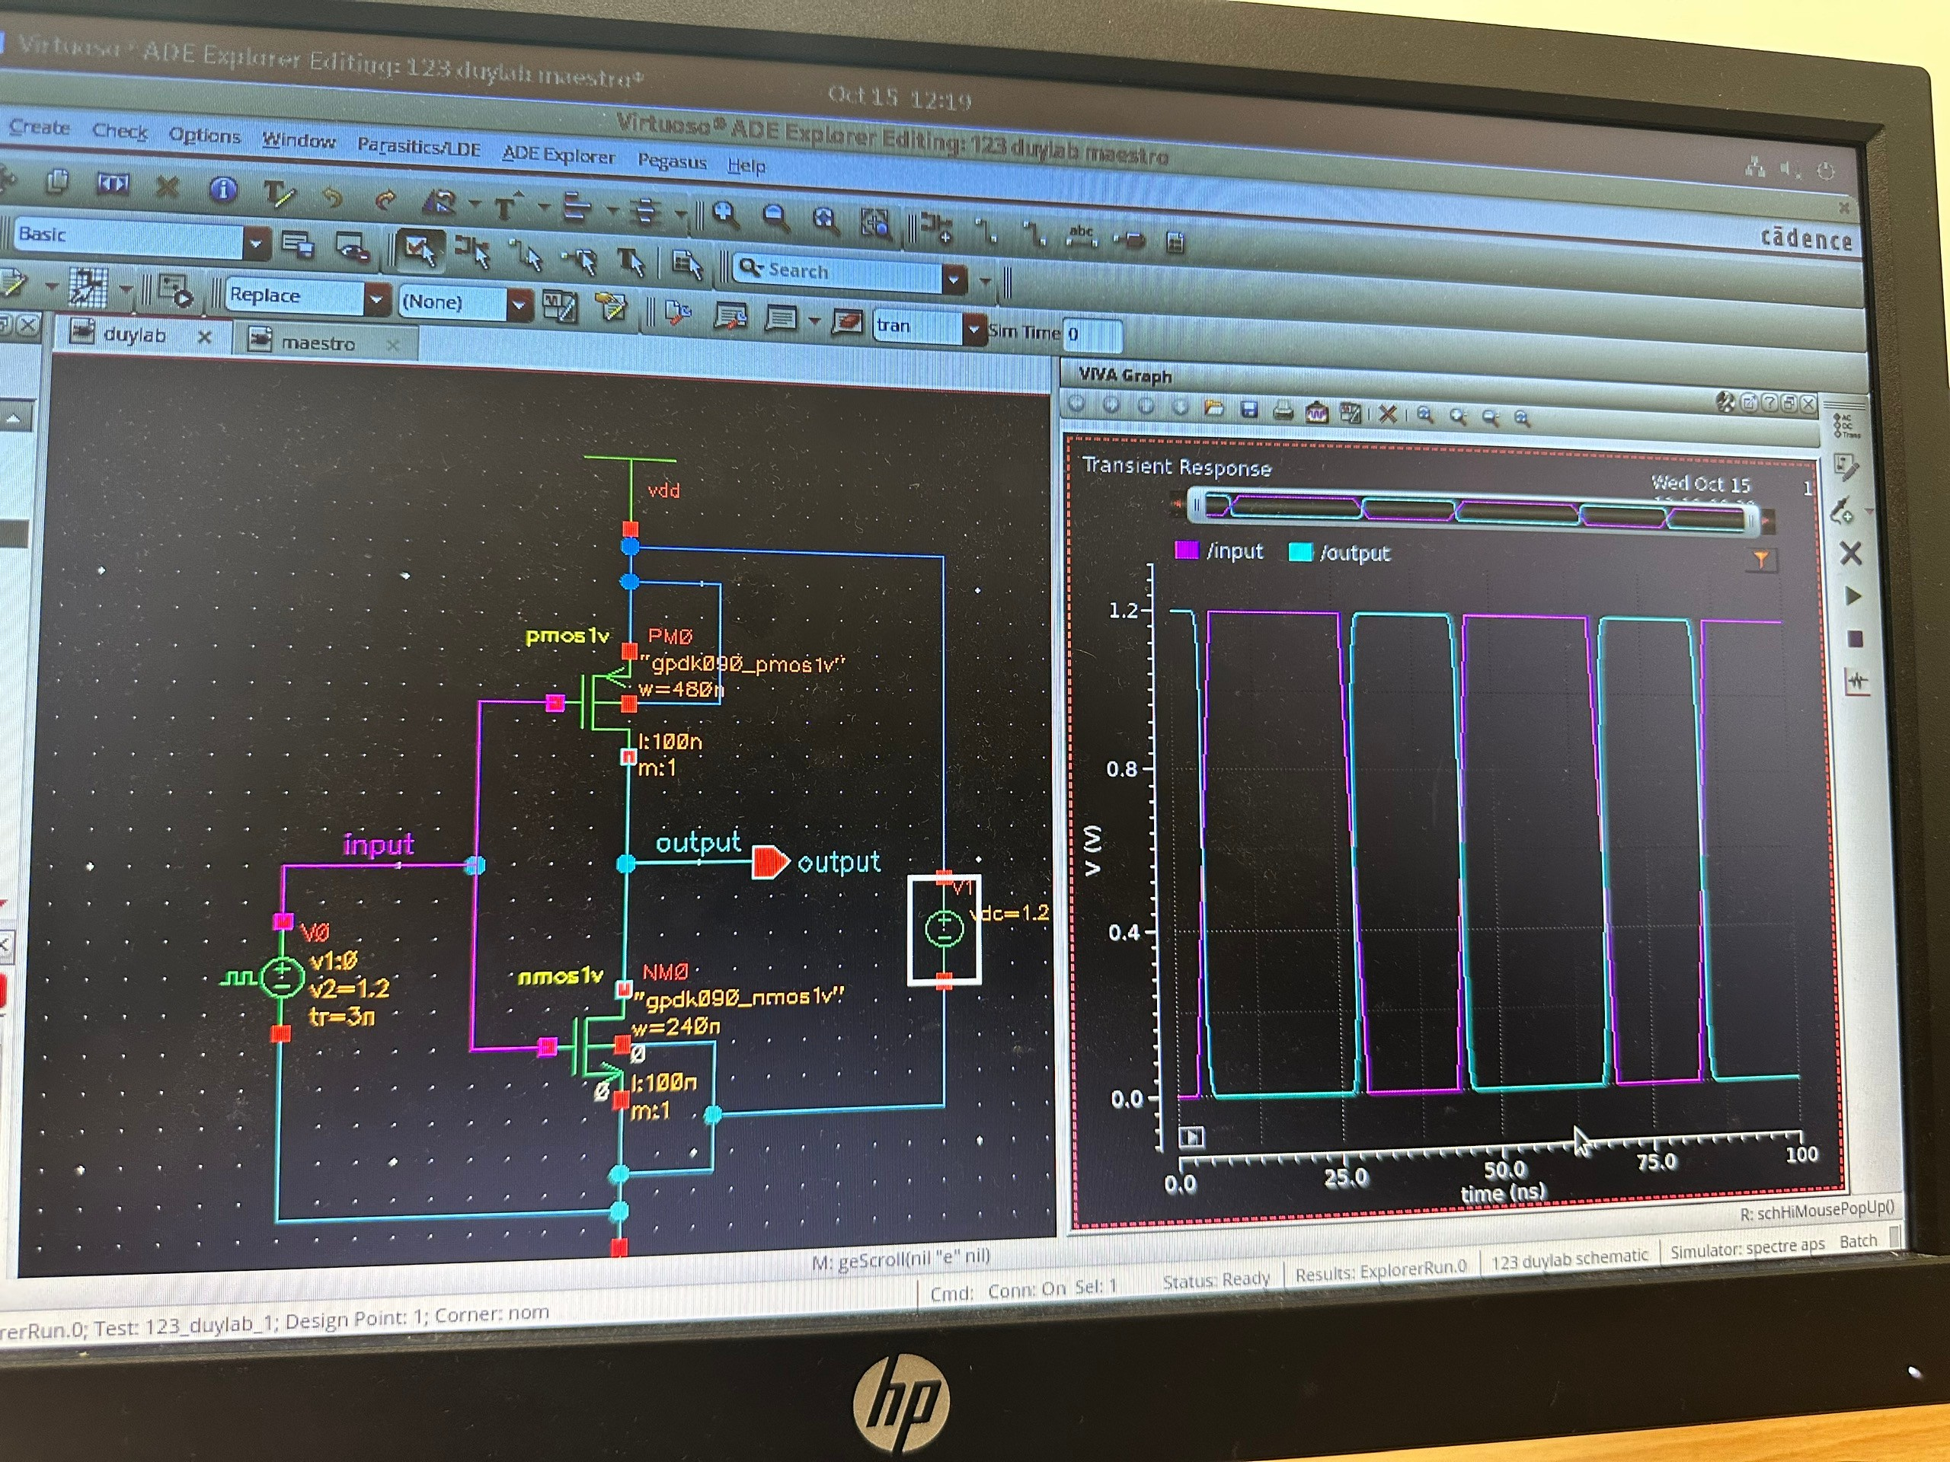The results clearly showed that increasing the width improves the drive strength, resulting in sharper rise and fall times. However, this likely comes at the cost of increased area and capacitance.

**4. Power Analysis**

I also performed a more detailed power analysis:

* **Dynamic Power:** I measured this during the switching activity of the transient response.
* 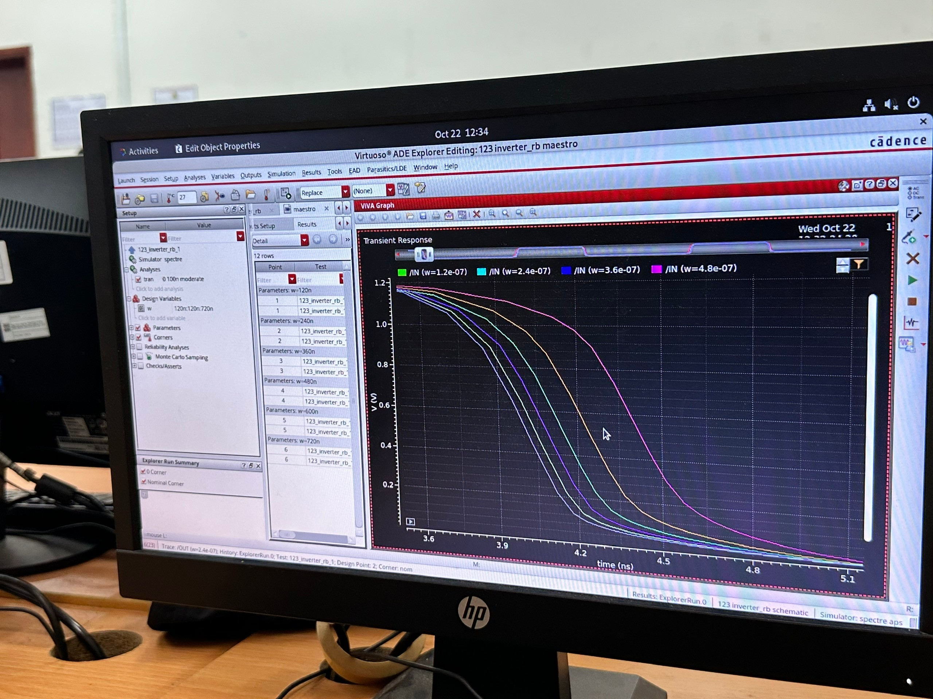**Static Power:** I ran a DC sweep on the input voltage ($V_{in}$) from 0 to 1.2V to observe the leakage current when the gate is not switching.